[All about Li-ion Battery Packs]

In this post I will be covering mainly about Li-ion cells and Battery packs, specially:

1. **Introduction to Battery management systems.**

Here, we will mainly be discussing about the proper management and control of battery packs: comprising of number of cells. Small and intelligent embedded systems used to control and manage the battery packs, are commonly known as Battery Management Systems (BMS). These modules implement complex algorithms to achieve its design purpose. A BMS must be responsible for the safety of operator, protect cells of battery in case of failure, prolong battery life, maintaining the battery in operating limits, and inform the host controller about how to make the best use the pack right now.

In a very basic application like flash light with rechargeable Nickel Cadmium battery do not require any kind of BMS to manage the battery, once the battery is drained out, just pull it out from the flash light, and recharge it and then place in the flash light, now it is ready to operate. However, Li-ion packs even in simpler application, it always needs a BMS system to manage and control it. Li-ion batteries are highly efficient as compared to lead acid and nickel metal hydride batteries that makes it market leader. Li-ion batteries cannot be overcharged or over discharged as nickel metal hydride. Doing so will catch fire in the Li-ion batteries. Hence, Li-ion batteries demand a complex BMS system even for a simpler applications that makes it expansive. However, the life of Li-ion batteries is so long that makes it cheaper as compared to the other batteries available in the current market.

Li-ion batteries are used in Hybrid-electric vehicle (HEV): where some other source like gasoline engine along with the li-ion batteries are used. Gasoline engine provides the average power required by the engine, while Li-ion batteries are used to provide power needed beyond average power. However, Li-ion batteries get charged when the required power is below the average power and do gets charged in case of breaking or moving down from a terrain.

Li-ion batteries are used in conjunction with the gasoline engine to enhance the operating torque and speed range, because gasoline engine alone efficiently operates in a very short torque and speed characteristics. Hence, the overall efficiency of Hybrid Electric vehicle (HEV) is much higher than the vehicle operating on gasoline engine.

As we discussed that the Li-ion battery is used to provide power to fulfill the power demand beyond average power, and HEV vehicle never runs alone on the battery. Therefore, HEV does not demand a very high power batter pack.

On the other hand, Plug-in hybrid electric vehicle (PHEV) demands for high power and larger batteries as compared to the HEV, because PHEV runs alone on the battery. However, there is some speed limit when PHEV is operating on battery. If we want to increase the speed beyond that limit value then we have to turn on the gasoline engine. There are some cars that operate over full speed and torque range on the battery only mode at the cost of higher battery pack and they are called as extended range electric vehicle (EREV). Lately, there are numerous cars in the market that runs fully on battery and specifically they are known as Electric Vehicle (EV) like: Tesla Model S. In 2001, there were only 2 HEV car models available in the whole US and neither were lithium ion. According the founder of Bloomberg New Energy Finance, Michael Liebreich, said that there will over 120 different model of Electric Vehicle (HE) will be available in the market by 2020.

So far we have discussed that the automotive industry is becoming more dependent on batteries and in order to efficiently utilize those battery packs, one has to manage and control it. This is why, the BMS are currently in high demand in these industries.

BMS design for Electric Vehicle must be carefully engineered, because Electric Vehicle battery’s voltage generally ranges from **200V to 600V** i.e. very high, and are supposed to handle **1000A** of peak current, while laptop and mobile devices operate on **15V-20V and 3.7V-5V** range respectively, however they also need BMS to manage and control the battery but these applications does not demand a complex BMS as the Electric Vehicle.

Batteries are also used to store the excess energy generated from the utility grids. This stored energy is used in case of excess load on the grids. However, batteries may not be a very good choice to be used with such high power utility grids. Battery use make more sense in the applications where micro generation of power at remote locations takes place. Another example that makes a very good sense is the use of battery to provide power backup: let say there is some problem at the local distribution station and maintenance is required. In this case, the whole area can be powered using a very large truck size mobile battery (Not implemented at this large scales but in future we may see this).

* 1. **Introduction to Battery terminologies:**

**Cells:** are smallest individual electrochemical unit, capable of delivering current at some voltage range depending upon the cell chemistry. Cells are of two types: one is called as primary cells because these cells are not rechargeable while other one is called as the secondary cell and they can be recharged.

NOTE: cell and battery are technically two different thing, a battery is comprised of many cells while a cell is the smallest electrochemical energy source.

**Battery:** a group of cells

**Nominal (kind of Average) Voltage and capacity:** depends on the combination of active chemicals used in the cell. **Capacity** specifies the quantity of charge, generally represented in mAh.

**C rate:** is relative measure of cell electrical current. It is constant current charge or discharge rate that the cell can sustain for one hour.

* Example: A 20Ah cell can deliver 20A for 1 hour---> 1C
* Or 2A for about 10hours --->C/10
* Or 40A for 0.5h---->2C
* If we are discharging a battery at 10C rate then the battery will be discharged in 6 minutes.
* If we discharge at 2C rate then the battery will be discharged at 0.5h=30minutes.
* If my battery takes 9h to fully charge then then I charged the battery at 1/9C rate.
* If a battery takes 6h to discharge completely then its C rating is 1/6C.
* This relationship is not strictly linear.

Just ask yourself that how much current I should draw/supply from/to the battery so that it gets fully discharged/charged in 1h. Let say you have “x”A, and your device is charging/discharging at “y”A then “y/x” is the C-rating.

If Z is the C-rating of the charger/load then it takes 1/Zh to charge/discharge the battery.

**Energy and power:** total energy of a cell is roughly equal to nominal voltage multiplied by nominal capacity and expressed in mWh, Wh, or kWh. While instantaneous power is the energy release or energy absorb rate and it is expressed in mW, W, or kW.

**Cells Connected in series:** capacity=individual capacity, voltage=sum of individual voltages

Let say a battery is constructed from three 3V, 20Ah cells in series:

Battery nominal voltage: 3x3=9v

Battery capacity: 20Ah

Battery nominal energy capacity: 9v x 20Ah=180 Wh

**Cells Connected in parallel:** capacity=sum of individual cell, voltage=individual cell

Let say the cell from the previous example are connected in parallel:

Battery nominal voltage: 3V

Battery capacity: 20x3=60Ah

Battery nominal energy capacity: 3x60=180Wh

* 1. **Parts of Electrochemical cell**

In order to make a very good understanding of how Li-ion batteries work, we need to look closely on electrochemical cell. The figure below shows the cross sectional view of electrochemical cell.

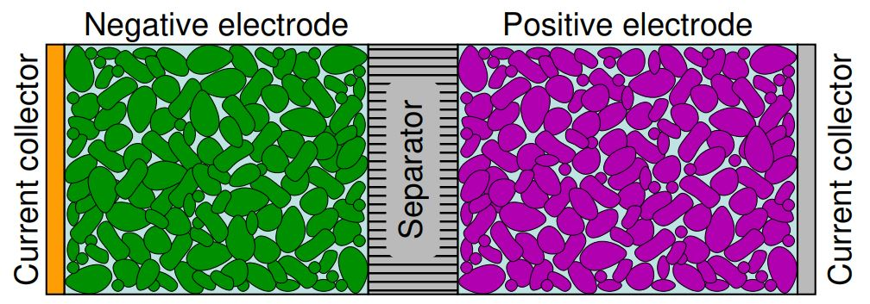

The region corresponds to the different items are colored with a different, are the actual color you are going to see once you open a cell. The different regions are:

* Negative electrode ---> green color
* Positive electrode ---> purple color
* Electrolyte-----> light blue color behind green, purple and grey
* Separator ----> horizontal lined grey region
* Current collectors ----> Orange(negative current collector: because it is generally made up of Copper and copper has orange color) and grey (positive current collector: because it is made up of Al that has grey color)

***Function of Negative electrodes:*** Cells operate by moving charge between their negative and positive electrodes. In regular electrochemical cells, negative electrodes are of metal or alloy of metal or hydrogen, while in lead acid cell (PbA) negative electrode is constructed by using lead metal or lead paste. During the charging process negative electrodes provides electrons to the external circuit, we can also say that negative electrodes is oxidized (OIL: oxidization is loss of electrons), while accepts electrons from the external circuit and gets reduced (RIG: reduction is gain of electrons) during charging process.

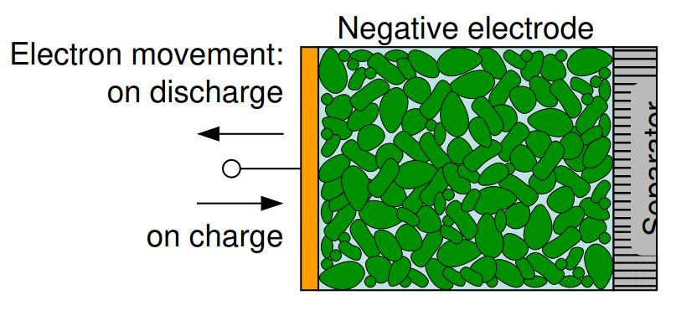

***Function of Positive electrodes:*** In electrochemical cells, positive electrode is constructed using metallic oxide, sulfide, or oxygen. Where as in lead acid (PbA) cells positive electrodes are made up of leas oxide. During discharging process it receives the electrons and releases electrons during charging process.

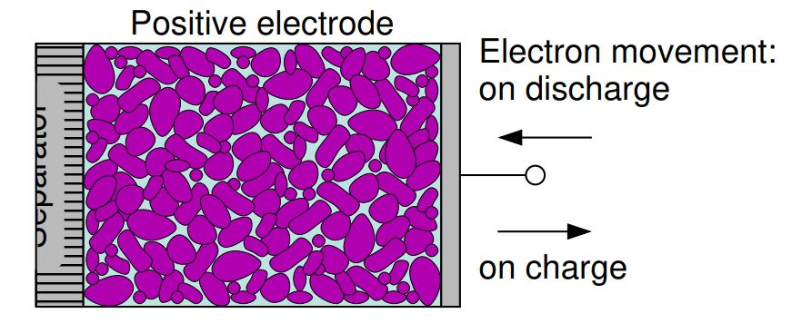

***Function of Electrolyte:*** As electrons move in external circuit, compensating ions must move internal to the cell. These ions are generated as the electron move from electrode or come into electrode. There are two types are ions cations (+ charge) that move through the electrolyte from the -electrode to the +electrode during discharging process and anions (- charge) that move through the electrolyte from the +electrode to the –electrode.

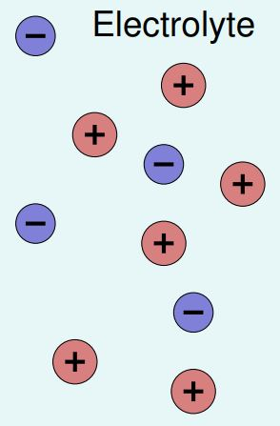

Electrolyte provides medium for the existence of cations and anions and for their movement. In Lead acid battery (PbA) cell, sulphuric acid diluted by water is used as electrolyte. Electrolyte should be a solvent that can completely dissolve to provide ionic conductivity for the cell operation like: acid, base, or salt. Electrolyte must be an electronic insulator to avoid moving of electron from one electrode to the other within the cell. If electrolyte is not an electronic insulator then it will self-discharge the cell.

***Function of Separator and current collectors:*** A separator is used to electrically isolate the two electrodes to avoid short circuit and self-discharge of the cell. Separator is made of porous mat or fiber, or polyethylene, or a polymer. Separator must be porous so that it allows the flow of ions from one side to the other through itself. Meaning, a separator should be such that it has very high impedance for electron movement and very low impedance for ion movement.

As we have discussed that the electrodes are made of powders and hence to connect the external circuitry to the cell, current collectors are used.

Example:

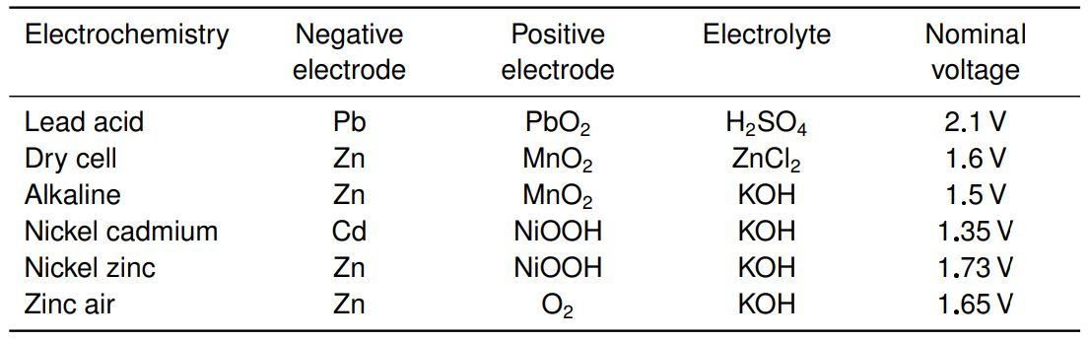

In lead acid case: Nominal voltage is dependent on the concentration of Sulphuric acid used as electrolyte. A 12v Vehicle battery is made of 6, 2V lead acid cell. The most interesting cell is the last one in the table because it uses air as positive electrode.

* 1. **How does an electrochemical cell store and release energy?**

In order to better understand: how does an electrochemical cell work, we need to first make a clear understanding of potential energy. The figure below shows a skateboarder on a parabolic path.

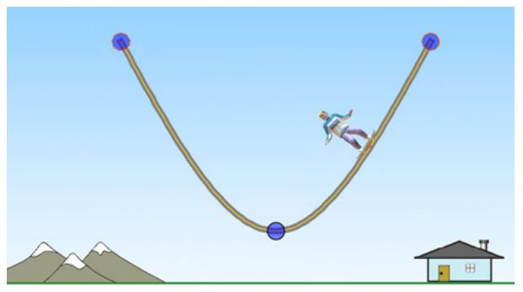

If the skateboarder is at the top of either of the side of parabolic path it has some potential energy to be released. Gravity is always trying to pull the skateboarder down at the lowest point i.e. lowest potential energy point. Although this example talks about the gravitational potential energy rather that talking about the electrochemical potential energy, this example helps in making an understanding of how potential energy in electrochemical works. Whenever a cell is fully charged (can say: the cell is at either of the top positions of parabola) it has potential energy at max and ready to be discharged. Fully discharged cell condition is similar to the skateboarder at the bottom position where gravity is trying to pull it down but it can’t and hence the cell cannot be further discharged.

* 1. **The discharging process: Potentials**

The electrochemical potential energy helps in releasing electron from the negative electrode and at the same time helps in generating the cations in the negative electrode region. Whenever, there is an external circuitry connected to the cell, flow of electrons starts from the negative electrode to the positive electrode. In case there is no external circuit present across the two terminals of the cell, it can be treated as the skateboarder at the top but there is some resistive force stopping him to get down.

Electrochemical potential energy difference between the two terminals of the battery is called as Voltage. And work is done when some electrical circuitry is externally connected to the cell because it favors the current flow to the external circuit. As we have discussed that the connecting external circuit to the cell, is equivalent to the removing motion hindering force applied to the skateboard. This result in work done by the gravity on the skateboarder.

**Rechargeable Cells**

**Primary cell:** are not rechargeable because the electrochemical reaction occurred during discharge process is not reversible. The chemical compound used in these cell are completely exhausted and changed during the discharging process. This is why primary cell can only be used once.

**Secondary cell:** are chargeable cells because the electrochemical reactions occurred during discharging process is reversible and once the cell is fully discharged the material only releases the electrochemical energy into the circuit but retains its compound quality. Hence, secondary cell can be used multiple time. Can we say that the secondary cell be used infinite number of times? No, because we only focuses the chemical reactions of our interest but there are number of reactions going on inside the cell that causes the quality degradation. The life of secondary cells are not determined by the main chemical reaction of our interest but it is mainly determined by how quickly the degradation processes occur.

Charging process can be understood as the apply force the skateboarder to move him to the top. This process is exactly the reverse of discharging process.

**Beware of overcharging and over discharging of a battery:**

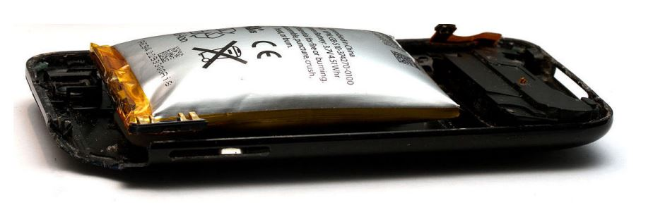

A cell should not be overcharge or over discharged, because this can cause an irreversible damage to the electrolyte of the cell and it may lead to fire, or explosion. To avoid this, battery manufacturers provide info on cell safe operation voltage range. However, overcharging a Lead Acid battery is not as harmful as the Li-ion battery, this is because when a PbA batter is over charged its electrolyte breaks into water and oxygen gas, and traps into the batter/cell chamber and good thing is that they recombine to form the same electrolyte (this happens within a certain voltage limit). Although, overcharging a PbA leads to the damage and explosion, over discharging is a serious issue of life of batter. Most of the applications maintains the proper state of charge of PbA battery: example in automotive grade 12V battery, to maintain the state of charge these batteries are not discharged below 20%. If we do not maintain a healthy state of charge of PbA battery, there is a formation of lead sulphate crystals on the electrodes and these crystals don’t usually breaks into original sulphuric acid using a normal 13.6V battery charger. In order to break these crystals a dedicated chargers are used that sends the high voltage pulses to the battery to break these crystals and these chargers are called as battery boosters.

Now we will be looking at how a battery is charged.

**CC/CV and CP/CV charging modes:**

Cells are often charged with constant power or constant current at the starting. In CC/CV (constant current/ constant power) mode: first battery is charges with the constant current that increases the voltage to a certain max level (the charged voltage of a battery) and then the current gets on reducing until the SOC(state of charge) is 100% or the battery is fully charged. While in CP/CV (constant power/ constant voltage mode) mode: first the cell is charged with the constant power and once cell voltage is reached to a certain max level (max charged cell voltage) then the power gets on reducing until the SOC (state of charge) is 100% or the cell is fully charged.

Now, its time to discuss about the possible use of materials inside the cell.

**Best materials used in electrochemical cells:**

**Designing cells electrochemistry:** battery electrochemistry should be designed in such that it optimize the following

* High specific energy and energy density (i.e. energy per unit mass and energy per unit volume).
* High specific power and power density.
* Low cost
* Long life
* Low toxicity
* High recyclability

Energy and power depends upon max cell voltage and current and rest of the factors are cell electrolyte and electrode materials dependent. For maximizing energy and power from a cell, one has to maximize the max voltage and current of the cell. Ultimately, how much current I can get from the cell depends upon how the cell is constructed, and how much voltage I can get depends upon the used electrode material.

NOTE: Energy defines how much work can be done and power defines how quickly that work can be done. Remember: voltage x current = power while voltage x current x time = energy.

For making a great understanding of voltage, we must first understand the electrode potential.

**Electrode potential:** The propensity of one material to lose or gain electrons relative to the other material.

Positive electrode: compound with positive electrode potential

Negative electrode: compound with negative electrode potential.

Greater the difference between electrode potentials of the two electrode, greater the voltage of the cell and greater the amount of energy stored in the cell.

Can it be said the the electrode potential can be possibly chosen? No, because of the available elements in nature. Let’s look at the periodic table:

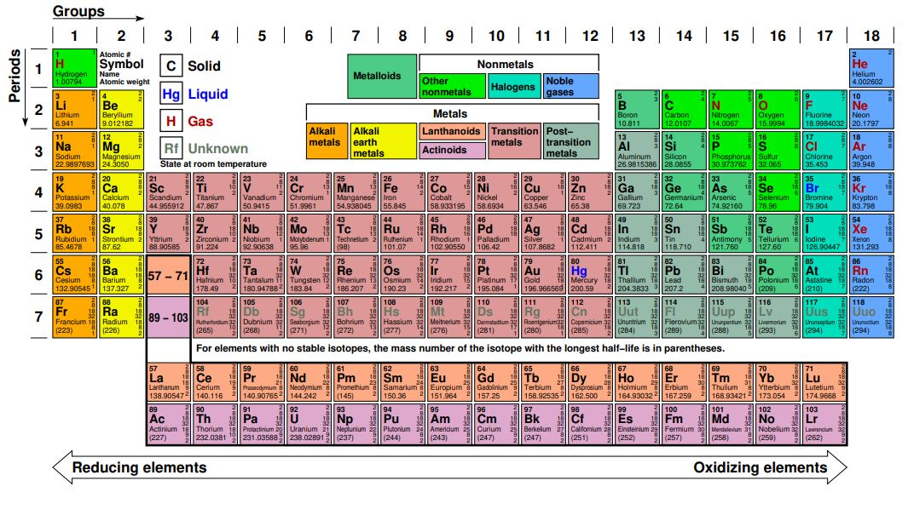

In this periodic table the elements are smartly arranged, where, the strong reducing elements are arranged in left and strong oxidizing elements are arranged in right. Hence, to make a high voltage cell one electrode should be chosen from the left most column while the other from the right most column.

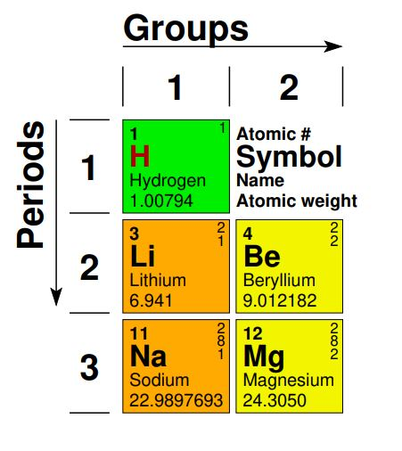

In the periodic table, elements are shown in different colored boxes with different colored symbols. Where, box color tells about whether the element is metallic, nonmetallic or metalloids and while element’s symbol color indicates whether the element is solid (black), liquid (blue) or gas (red). On the top left corner of the box, atomic number is shown, and on the top right corner a list of number is shown that represents the shell configuration of that element. Moreover, under the symbol and its corresponding name, atomic weight is given. Atomic weight is defined as the sum of weight of protons, neutrons and electrons. Due to negligible weight of electrons, atomic weight is calculated by using the weight of protons and neutrons. Atomic weight of proton or neutron is equal to 1g per mole and one mole is defined as the 6.022*10^23(Avogrado number) atoms. This number is chosen such that the weight of 6.022*10^23 proton/neutron becomes 1g.

Worth remembering: atomic weight is always written as mean value, because weight of neutron varies for the same element from the sample to sample.

In periodic table, each row is called as period and represented by an integral number starting from 1. All the elements sharing the same periodic number have the same number of electron shell and the period number represents the number of electron shell .On the other hand, each column is called as group and represented by an integral number starting from 1. All the element from same group generally have same number of valance electrons (electrons in the outer most shell of electronic shell configuration). Valance electrons play a vital role in determining how element react with the others and hence generally same group elements show the same chemical property. Surprisingly, noble gases doesn’t react at all because their valance shell is full and these elements are also known as inert gases. Electronic shell configuration of Li, C and Cobalt is shown below as an example:

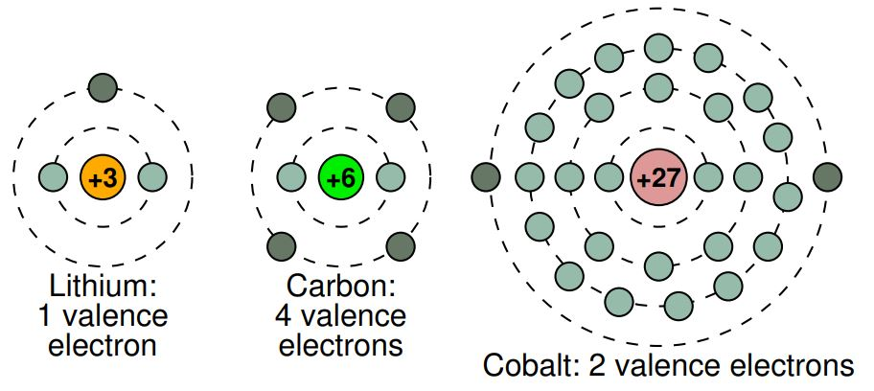

These three elements are purposely chosen because these are widely used in the industry. Li is used as electrolyte in Li-ion cell, electrode of Li-ion cell is made up of some form of carbon and lastly positive electrode of Li-ion cell is made up of high proportion of cobalt.

1. **Equivalent circuit cell model simulation using MATLAB/OCTAVE.**
2. **Battery State-of-Charge (SOC) estimation.**
3. **Battery State-of-Health (SOH) estimation.**
4. **Battery pack balancing and power balancing.**